**1.Find the average age of churned customers**

The average age of customers who have churned is approximately 49.74 years, suggesting that middle-aged individuals may be more prone to leaving the service.

**SQL Query:**

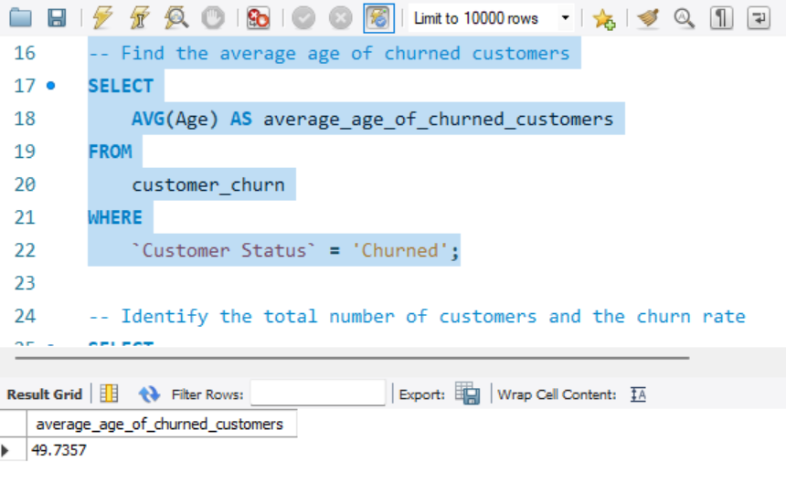

**Results:**

* Average Age of Churned Customers: 49.7357 years

**2. Identify the total number of customers and the churn rate**

Out of 7,043 total customers, approximately 26.54% have churned. This indicates that more than a quarter of the customer base has discontinued their service.

**SQL Query** 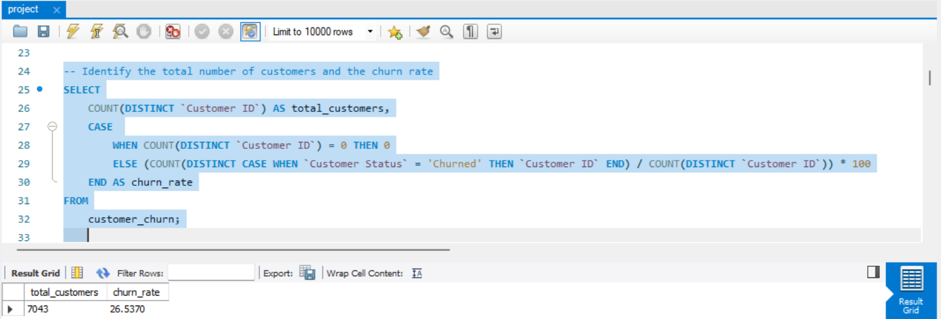

**Results:**

* **Total Customers:** 7043 & **Churn Rate:** 26.5370%

**3. Discover the most common contract types among churned customers**

The majority of churned customers had a Month-to-Month contract, indicating that customers with more flexible, short-term contracts are more likely to churn compared to those with longer-term commitments.

**SQL Query:**

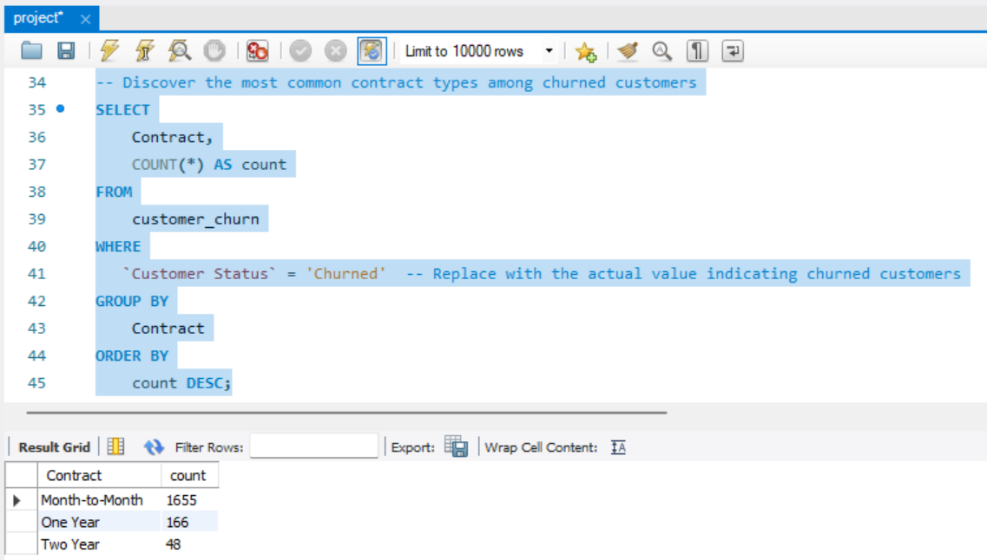

**Results:**

* **Month-to-Month Contract:** 1,655 churned customers (the most common).
* **One Year Contract:** 166 churned customers.
* **Two Year Contract:** 48 churned customers.

**4. Analyze the distribution of monthly charges among churned customers**

Churned customers are concentrated in the 19-80 charge range, with notable spikes at certain values. Further analysis could explore the reasons behind these charge patterns.

**Data Summary:**

The table below summarizes the number of churned customers for each monthly charge:

|  |  |
| --- | --- |
| **Monthly Charge** | **Number of Customers** |
| -10 | 2 |
| -9 | 2 |
| -8 | 2 |
| -7 | 6 |
| -5 | 3 |
| -4 | 5 |
| -3 | 1 |
| -2 | 2 |
| -1 | 7 |
| 18.85 | 1 |
| 18.95 | 1 |
| 19 | 1 |
| 19.1 | 1 |
| 19.25 | 3 |
| 19.3 | 3 |
| 19.35 | 2 |
| 19.4 | 3 |
| 19.45 | 3 |
| 19.5 | 2 |
| ... | ... |
| 118.35 | 1 |

**Key Observations:**

* **Range of Charges:** Monthly charges for churned customers range from -10 to 118.35, with most falling between 18 and 80.
* **Charge Frequencies:** High frequencies are seen around 19 to 30 and 70 to 80, with peaks at 74.4 (13 customers), 45.3 (8 customers), and 70.35 (7 customers).
* **Extreme Values:** Outliers like -10 and 118.35 stand out from the rest of the data.

**SQL Query:**

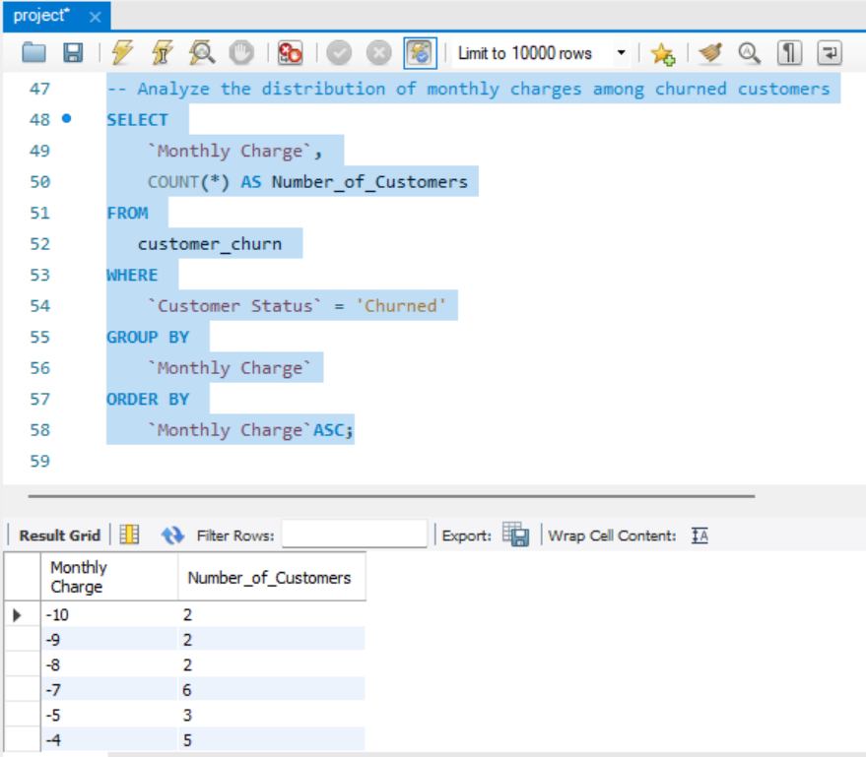

**5. Create a query to identify the contract types that are most prone to churn**

**Month-to-Month** contracts have the highest churn rate by far, indicating that customers with more flexible contracts are more likely to leave. In contrast, customers with longer-term commitments (One Year and Two Year) have significantly lower churn rates, suggesting they may feel more committed or satisfied with the service.

**Churned Customers by Contract Type:**

* **Month-to-Month:** 1,655 churned customers
* **One Year:** 166 churned customers
* **Two Year:** 48 churned customers

**SQL Query:**

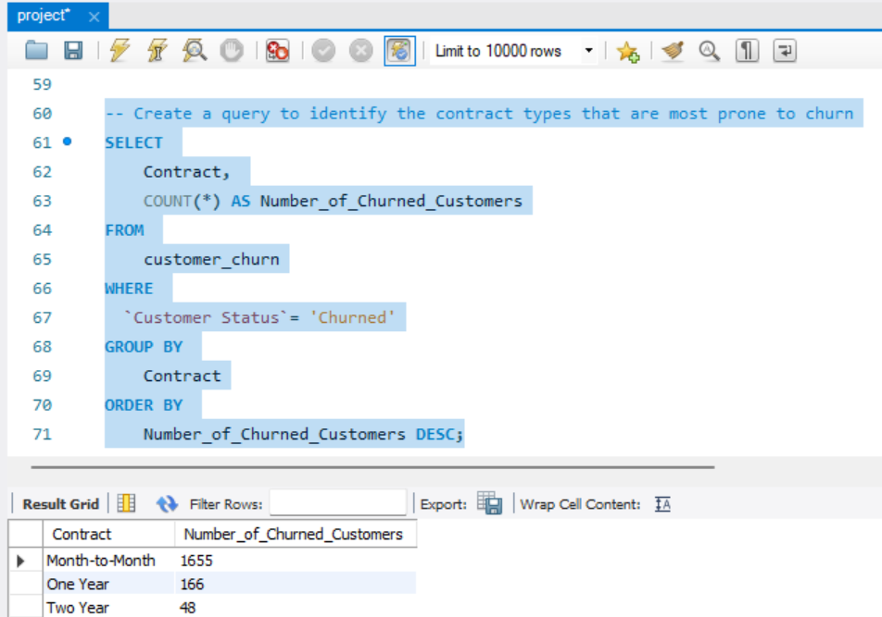

**6. Identify customers with high total charges who have churned**

**Data summary:**

|  |  |  |  |  |
| --- | --- | --- | --- | --- |
| **Customer ID** | **Total Charges** | **Contract** | **Customer Status** | **Churn Reason** |
| 5287-QWLKY | 7548.1 | Month-to-Month | Churned | Attitude of support person |
| 5502-RLUYV | 7446.9 | Month-to-Month | Churned | Competitor made better offer |
| 9090-SGQXL | 7299.65 | Month-to-Month | Churned | Competitor offered more data |
| 3838-OZURD | 7133.25 | Month-to-Month | Churned | Competitor had better devices |
| 7752-XUSCI | 6396.45 | Month-to-Month | Churned | Don't know |
| 2889-FPWRM | 8684.8 | One Year | Churned | Competitor offered higher download speeds |
| 0201-OAMXR | 8127.6 | One Year | Churned | Network reliability |
| 3886-CERTZ | 8109.8 | One Year | Churned | Competitor had better devices |
| 1444-VVSGW | 7968.85 | One Year | Churned | Product dissatisfaction |
| 0748-RDGGM | 7534.65 | One Year | Churned | Long distance charges |
| 5271-YNWVR | 7856 | Two Year | Churned | Extra data charges |
| 9053-JZFKV | 7752.3 | Two Year | Churned | Don't know |
| 1555-DJEQW | 7723.9 | Two Year | Churned | Price too high |
| 8809-RIHDD | 7372.65 | Two Year | Churned | Lack of affordable download/upload speed |
| 2225-ZRGSG | 6579.05 | Two Year | Churned | Long distance charges |
| 3768-NLUBH | 5746.15 | Month-to-Month | Churned | Network reliability |
| 0407-BDJKB | 5742.9 | Month-to-Month | Churned | Service dissatisfaction |
| 9651-GTSAQ | 5769.75 | One Year | Churned | Attitude of support person |
| 8079-XRJRS | 5769.6 | One Year | Churned | Network reliability |
| 8849-GYOKR | 5763.3 | One Year | Churned | Product dissatisfaction |

**Summary of Results: High Total Charges and Churn Analysis**

The provided dataset focuses on randomly selected customers with high total charges, ranging from 5700 to 8648, across different contract types (Month-to-Month, One Year, Two Year). The dataset highlights customers who have churned along with the associated churn reasons. Key findings show that **Month-to-Month** contracts have the highest churn rates, primarily due to better offers from competitors and issues like network reliability. In **One Year and Two Year** contracts, factors like higher download speeds offered by competitors, price dissatisfaction, and additional charges drive churn.

**Insights:**

* **Competitor Influence:** A significant portion of churn reasons relates to competitors offering better deals, devices, or data options. This trend is especially strong in month-to-month and one-year contracts.
* **Service and Support Issues**: Customer dissatisfaction due to support quality and service reliability also plays a major role in churn across all contract types.
* **Price Sensitivity in Long-Term Contracts:** Two-year contract holders are more likely to leave due to high prices and additional fees.

**SQL Query:**

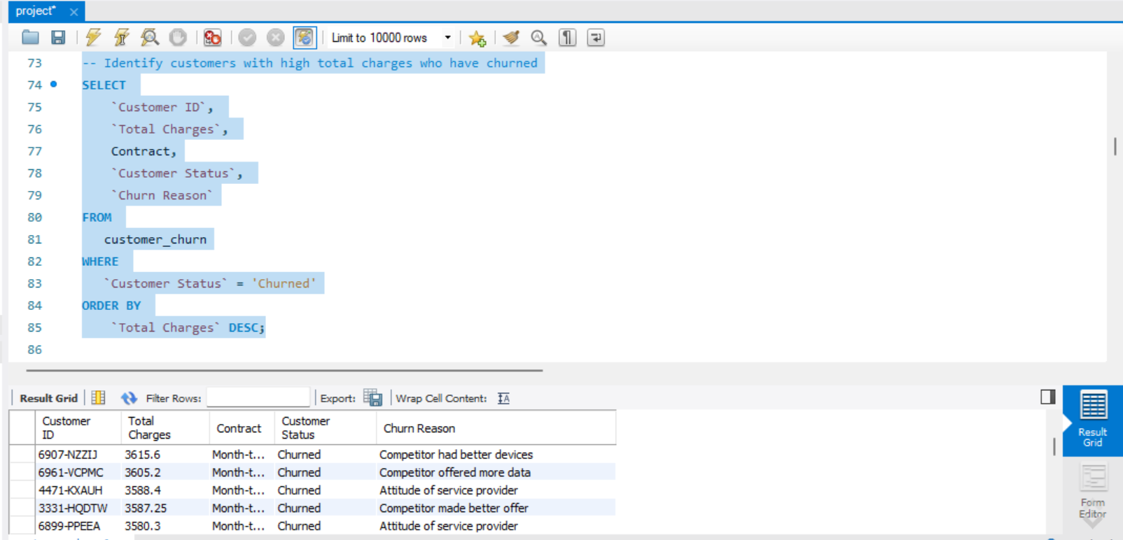

**7.**  **Calculate the total charges distribution for churned and non-churned customers**

**Data Summary:**

|  |  |  |  |  |  |
| --- | --- | --- | --- | --- | --- |
| **Customer Status** | **Number of Customers** | **Min Charges** | **Max Charges** | **Avg Charges** | **Total Charges Sum** |
| Stayed | 4720 | 55.7 | 8672.45 | 2788.516831 | 13161799.44 |
| Churned | 1869 | 18.85 | 8684.8 | 1531.796094 | 2862926.9 |
| Joined | 454 | 18.8 | 335.75 | 79.29273128 | 35998.9 |

**Stayed Customers:**

* These customers have the highest average and total charges, indicating that they likely represent long-term, high-value customers.

**Churned Customers**:

* Churned customers have lower average charges compared to those who stayed. However, their maximum charges are comparable to the stayed group, suggesting that even high-paying customers may churn due to dissatisfaction or other factors.

**Joined Customers**:

* Joined customers have the lowest average charges, reflecting that they are in the initial stages of their service usage.

**Conclusion:**

The data highlights a clear distinction between customer statuses. Customers who stayed have the highest charges, while churned customers show a mix of low and high charges, indicating that dissatisfaction can drive both low and high-value customers to leave. Newly joined customers have minimal charges, as expected for new users.

**SQL Query:**

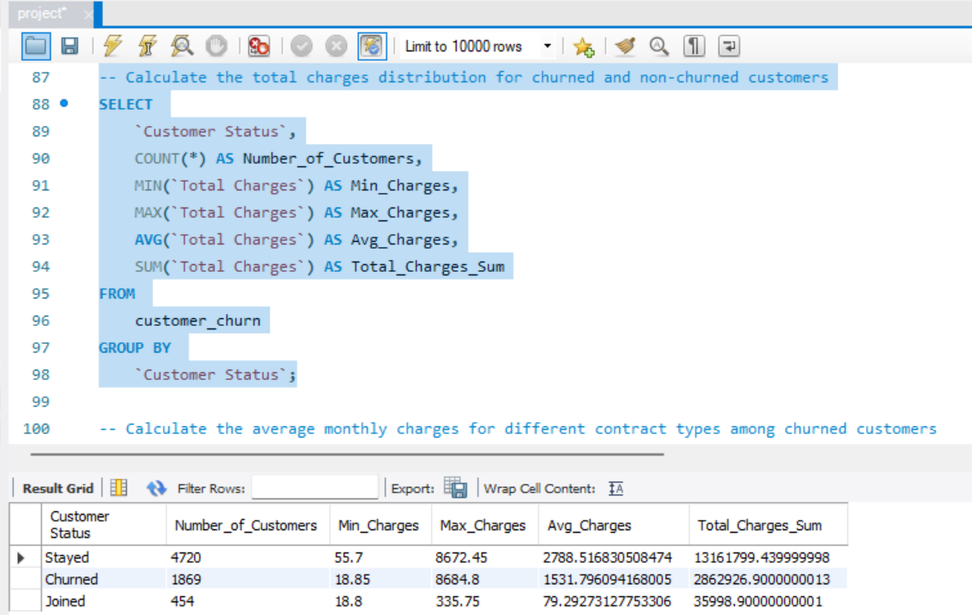

**8. Calculate the average monthly charges for different contract types among churned customers**

**Data Summary:**

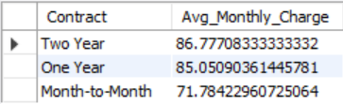

Longer contracts (one-year and two-year) have higher average charges among churned customers, indicating that high charges alone do not guarantee customer retention. Month-to-month contracts, while more affordable, see higher churn rates possibly due to their flexible nature.

**Two-Year Contracts**:

* **Average Monthly Charge**: $86.78
* Customers with two-year contracts have the highest average monthly charges among churned customers. This suggests that even long-term contract holders, who pay higher rates, are susceptible to churn.

**One-Year Contracts**:

* **Average Monthly Charge**: $85.05
* One-year contract holders have slightly lower average monthly charges than two-year contracts but are still relatively high compared to month-to-month customers.

**Month-to-Month Contracts**:

* **Average Monthly Charge**: $71.78
* Month-to-month contracts have the lowest average charges among churned customers. This contract type is more flexible and might attract customers with lower commitment levels, who are more likely to churn.

**SQL Query:**

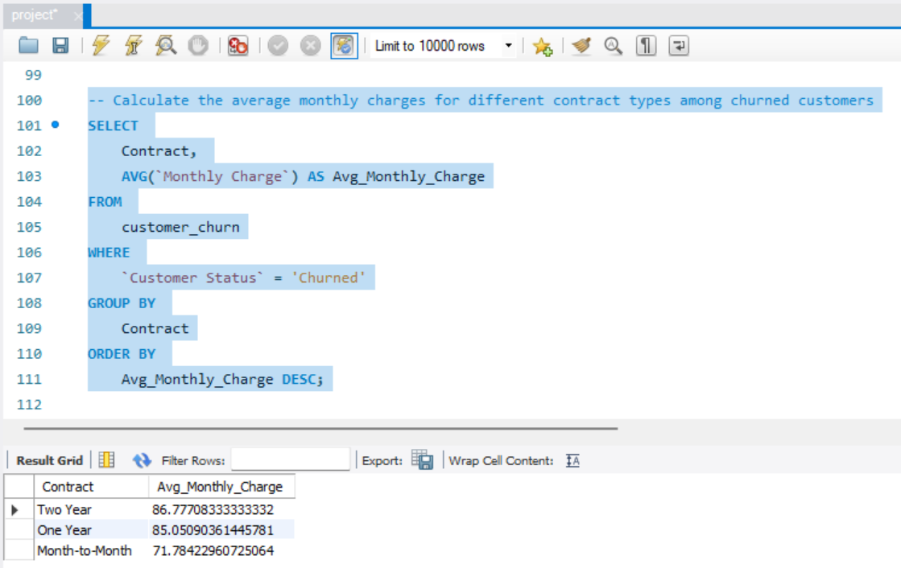

**9. Identify customers who have both online security and online backup services and have not churned**

A total of **997 customers** have both **online security** and **online backup services** and have not churned. These customers represent a segment that values additional protection and data safety features, indicating that such services may contribute to customer retention. Offering bundled security and backup services seems to positively impact customer loyalty and reduce churn rates, as customers who invest in these additional features are less likely to leave.

This insight suggests that focusing on promoting these bundled services could be an effective strategy for enhancing customer satisfaction and reducing churn.

**SQL Query:**

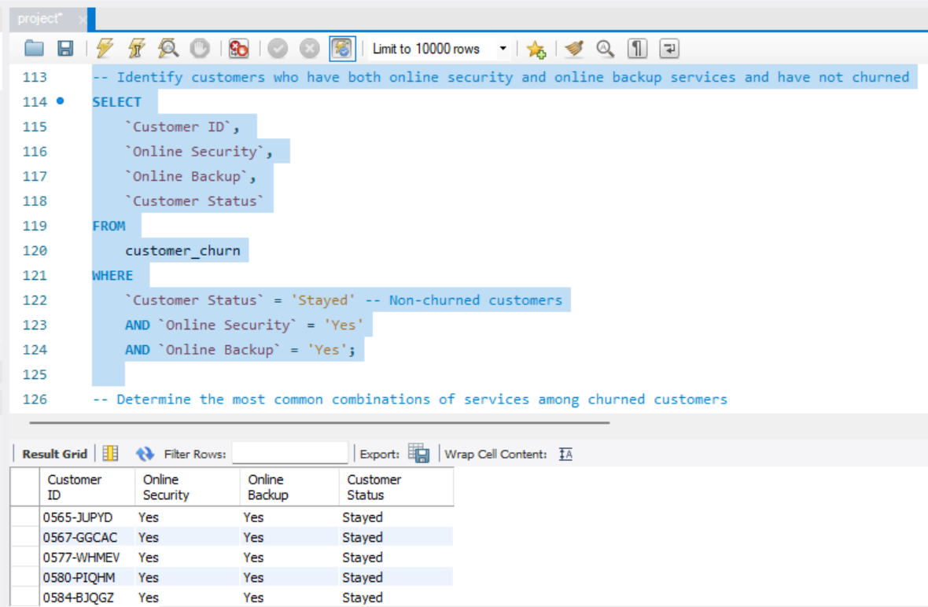

**11.  Identify the average total charges for customers grouped by gender and marital status**

**Data Summary:**

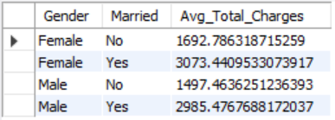

* Married females have the highest average total charges of 3073.44.
* Married males follow closely with an average total charge of 2985.48.
* Single females have an average total charge of 1692.79.
* Single males have the lowest average total charge of 1497.46.

The data suggests that married customers, regardless of gender, tend to have higher total charges compared to single customers. This could be indicative of higher service usage or longer tenure among married individuals.

**SQL Query:**

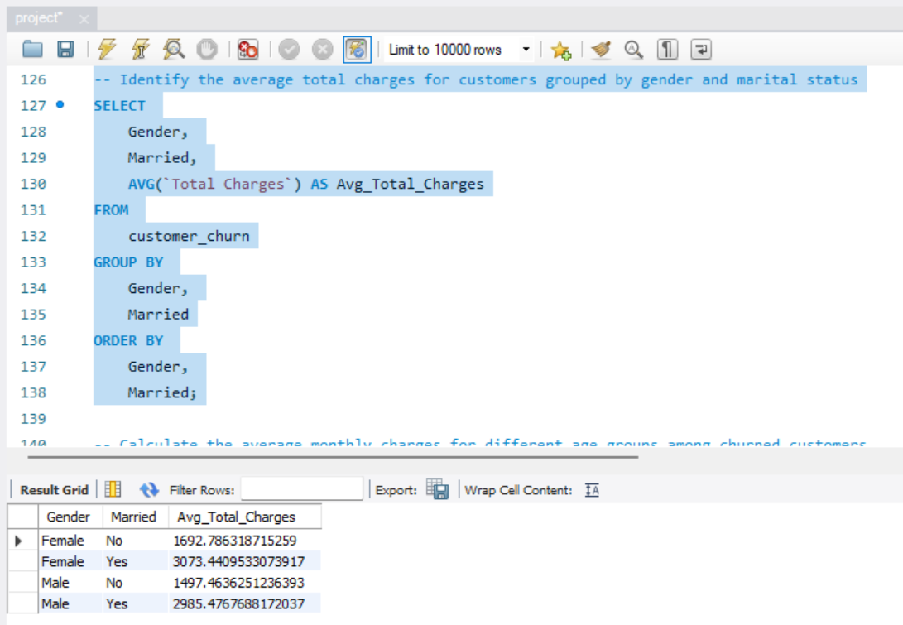

**12.  Calculate the average monthly charges for different age groups among churned customers**

**Data Summary:**

|  |  |
| --- | --- |
| **Age_Group** | **Avg_Monthly_Charge** |
| 46-55 | 71.26184615 |
| 56 and above | 76.65087248 |
| 26-35 | 71.18559603 |
| 36-45 | 70.65716612 |
| 18-25 | 71.74657895 |

* The **56 and above** age group has the highest average monthly charges among churned customers, indicating they might be on more expensive plans.
* The **36-45** age group has the lowest average monthly charges, which might suggest different usage patterns or preferences compared to other age groups.
* The average monthly charges for the remaining age groups are quite similar, with slight variations.

**SQL Query:**

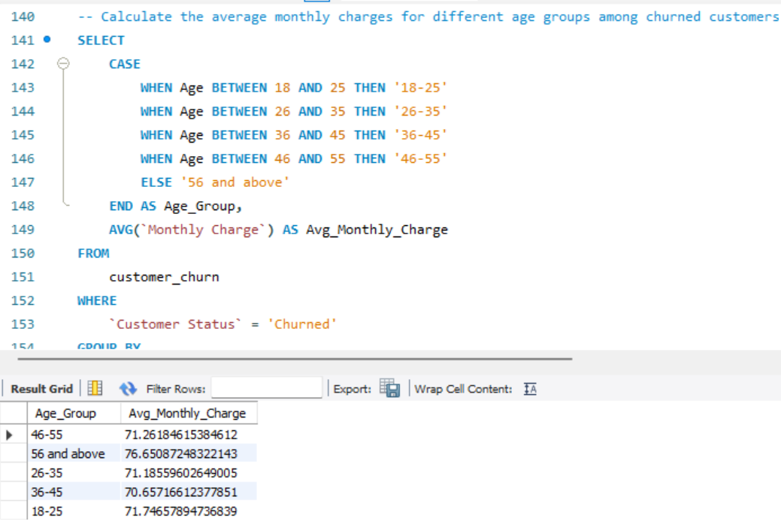

**15.  Calculate the average monthly charges for customers who have multiple lines and streaming TV**

**Summary of Result:**

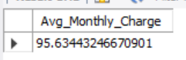

* **Average Monthly Charge:** Customers with multiple lines and streaming TV have an average monthly charge of $95.63.
* This higher average charge suggests that customers who opt for multiple lines and streaming TV services are likely using a more premium or comprehensive service package.
* The presence of both multiple lines and streaming TV in a customer's plan might indicate a higher engagement level with the service provider, possibly reflecting a need for more extensive or bundled services.
* These customers may represent a more valuable segment for the company, and understanding their needs could be key in both retention efforts and upselling additional services.

This insight could be beneficial for targeting specific customer segments with tailored offers or retention strategies, particularly focusing on those who are already utilizing multiple services.

**SQL Query:**

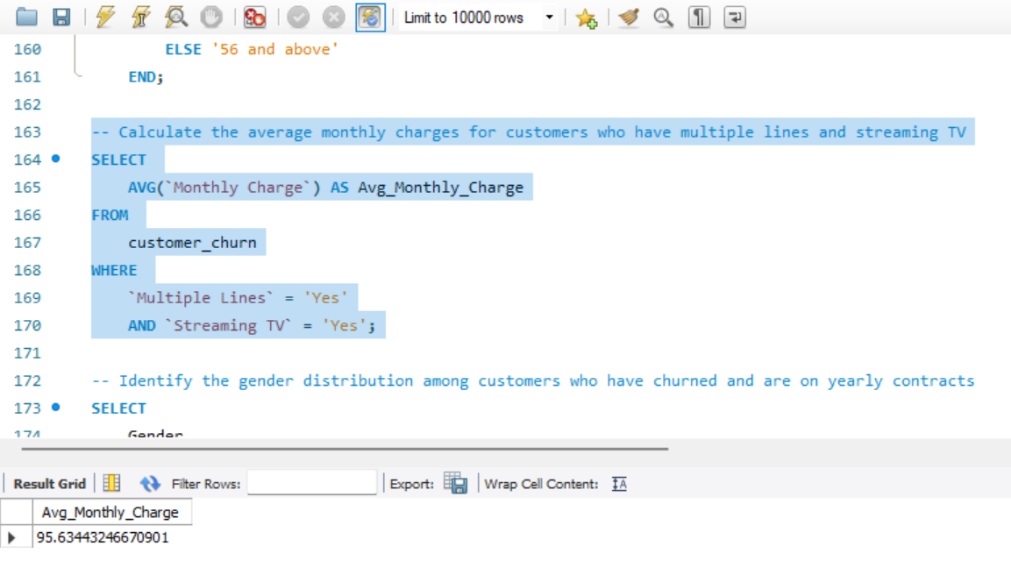

**21.  Calculate the average monthly charges and total charges for customers who have churned, grouped by the number of dependents**

**Data Summary:**

|  |  |  |
| --- | --- | --- |
| **Number of Dependents** | **Avg_Monthly_Charge** | **Total_Charges** |
| 0 | 74.21687465 | 2780711.6 |
| 1 | 64.09605263 | 44301.95 |
| 2 | 60.97575758 | 20114.4 |
| 3 | 51.69833333 | 16312.2 |
| 4 | 95 | 655.5 |
| 6 | 34.5 | 279.25 |
| 7 | 19.25 | 19.25 |
| 5 | 47.375 | 532.75 |

* Customers with **0 dependents** have the highest total charges, making them the most significant segment among churned customers. However, their average monthly charge is moderate.
* As the number of dependents increases from **1 to 3**, both average monthly charges and total charges generally decrease, suggesting that customers with more dependents might be opting for less expensive plans or using fewer services.
* The **4-dependents** group stands out with a high average monthly charge, but the total charges are very low, indicating this is likely a small or unique segment.
* Groups with **5 or more** dependents have notably lower average and total charges, indicating either very limited-service usage or a very small customer base.

**SQL Query:**

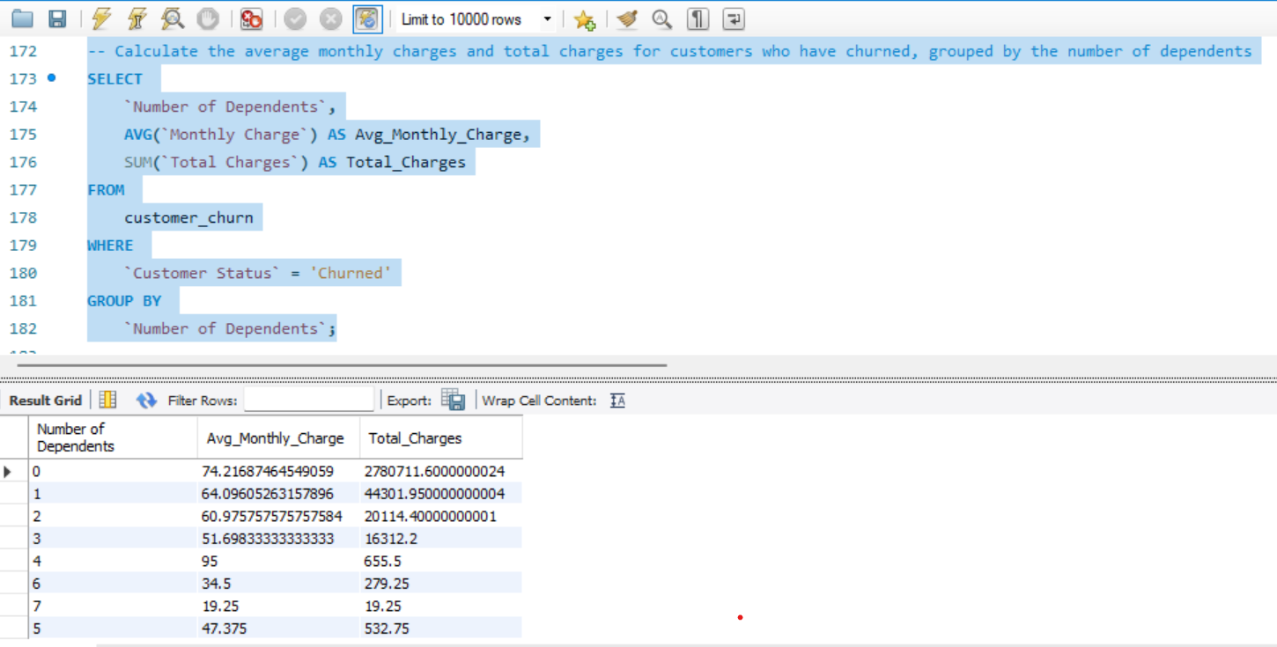

**22.  Identify the customers who have churned, and their contract duration in months (for monthly contracts)**

**Summary:**

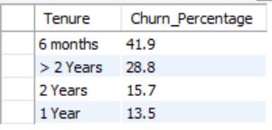

* **High churn** in the initial 6 months could indicate the need for better onboarding or early customer engagement strategies to reduce early churn.
* **Moderate churn** after 1 year suggests a retention window where customers are relatively stable but may need attention as they approach the 2-year mark.
* **Increased churn** after 2 years could indicate a cycle where customers reassess their service needs or shop around for better deals, necessitating targeted retention offers for long-term customers.

**SQL Query:**

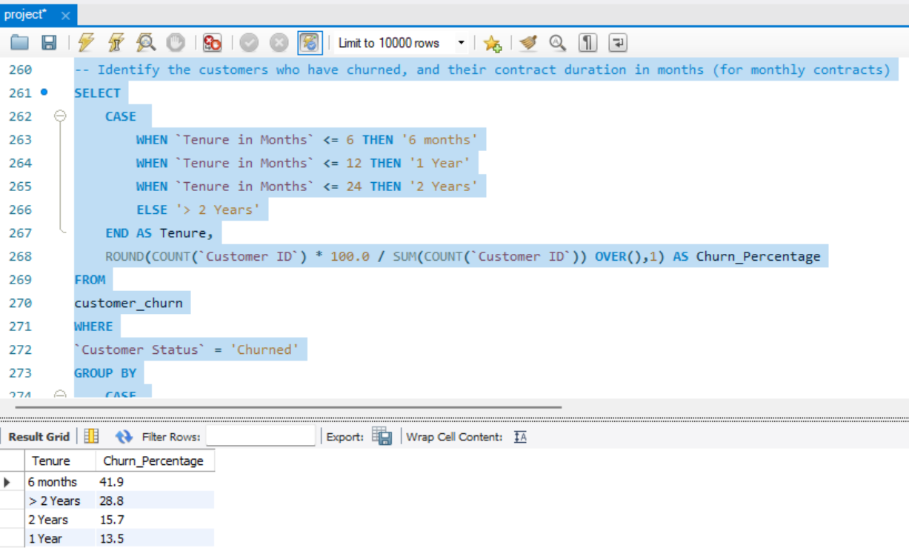

**23.  Determine the average age and total charges for customers who have churned, grouped by internet service and phone service**

**Summary of Results:**

1. **Customers with both Internet and Phone Service (Yes, Yes):**
   * **Average Age:** 50.17 years
   * **Total Charges:** $2,724,690.00
   * **Insight:** This group has the highest total charges, indicating that customers with both internet and phone services are a significant revenue source. Their average age is around 50 years, suggesting they are likely mature customers with possibly higher service needs.
2. **Customers with Internet Service only (Yes, No):**
   * **Average Age:** 49.89 years
   * **Total Charges:** $1,168,045.90
   * **Insight:** The total charges are substantial, but significantly lower than those who also have phone service. The average age is similar to those with both services, suggesting that customers who churned with only internet service might have slightly different service requirements.
3. **Customers with Phone Service only (No, Yes):**
   * **Average Age:** 43.47 years
   * **Total Charges:** $196,529.50
   * **Insight:** This group has the lowest total charges and a lower average age, indicating that younger customers who only have phone service might have lower overall service usage or spending.

**Overall Insights:**

* **High total charges** are associated with customers who subscribe to both internet and phone services. These customers also tend to be older, which may correlate with higher service consumption or more comprehensive service plans.
* **Churned customers with only one service** (either internet or phone) tend to have lower total charges, with those having only phone service showing the lowest charges and being younger on average.
* **Retention strategies** may need to be tailored differently for each group, with a focus on maintaining high-value customers who subscribe to both services and understanding the needs of younger customers who may prefer only phone services.

**SQL Query:**

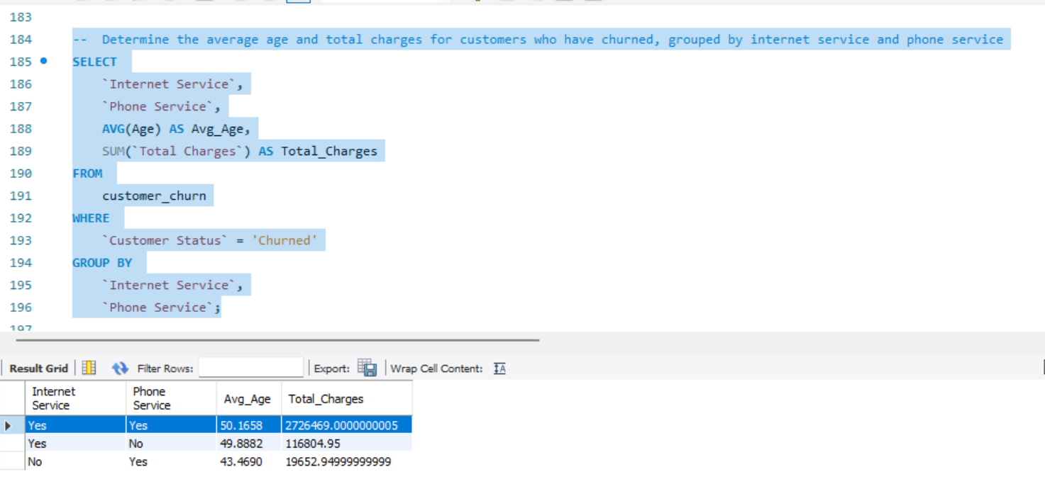

**25.  Create a view to identify customers who have churned and the average monthly charges compared to the overall average**

**Visualization:**

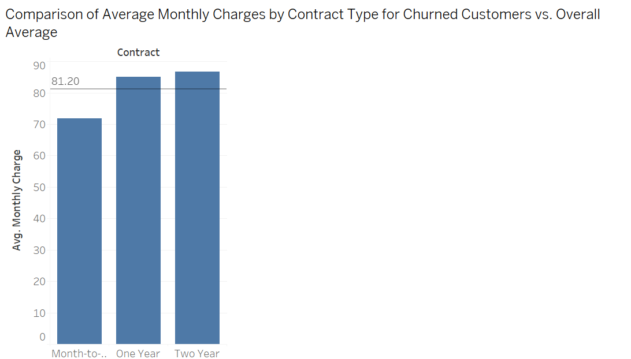

**26.  Create a view to find the customers who have churned and their cumulative total charges over time**

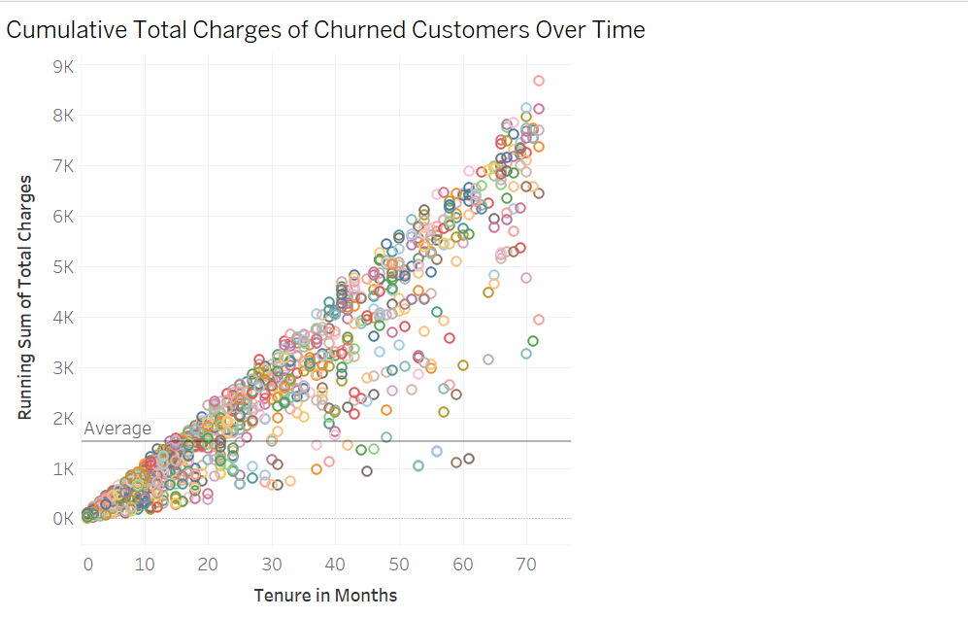

**Revenue Lost Due to Churned Customers**

**Summary:**

Based on the analysis, 17.24% of the total revenue has been lost due to customer churn. This indicates that nearly one-fifth of the company's potential revenue is being lost as customers discontinue their services.

**Key Insights:**

* **Significant Impact:** A revenue loss of 17.24% due to churn is substantial, highlighting the importance of addressing the factors driving customers to leave.
* **Strategic Focus:** To mitigate this loss, the company should focus on key areas such as improving customer satisfaction, enhancing service offerings, and implementing retention strategies to reduce churn rates.
* **Opportunity for Improvement:** By reducing churn, even a small percentage improvement can translate into a considerable financial gain for the company**.**

**SQL Query:**

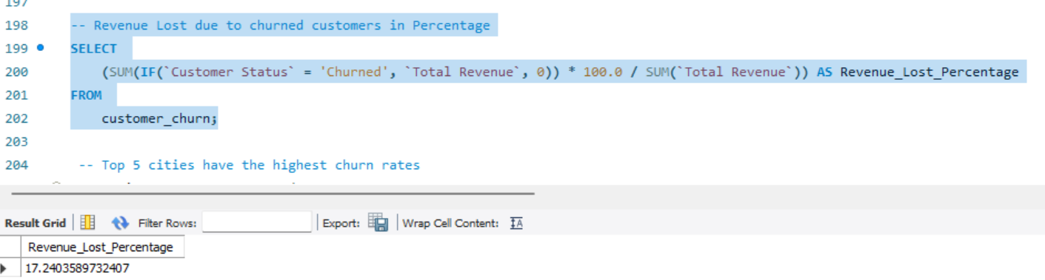

**Top 5 cities have the highest churn rates**

**Data Summary:**

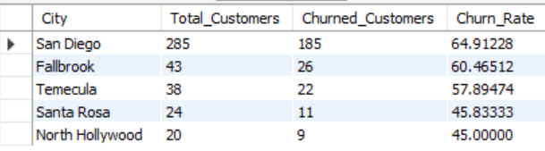

For the purpose of this analysis, I only considered cities with more than 20 customers in total, because some cities had very few customers and my conclusion would have been biased towards them.

• **San Diego** had the highest churn rate at 65%, which means that over half of their customers have left the company.

• **High churn rates** across these cities suggest potential issues with service satisfaction, competitive pressures, or other factors driving customers away.

• Smaller cities like **Fallbrook** and **Temecula** also show concerning churn rates, indicating that even in less populated areas, customer retention is a challenge.

• **Santa Rosa and North Hollywood** have slightly lower churn rates but still indicate areas where customer retention could be improved.

**SQL Query:**

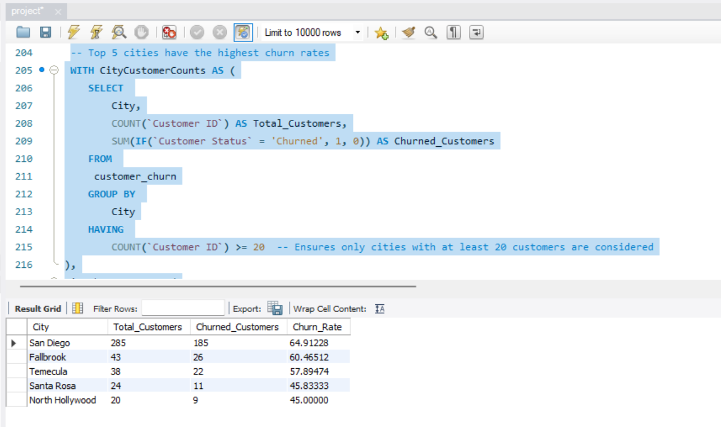

**Major Churn Reasons – TOP 3**

**Summary of Major Churn Reasons:**

1. **Top Reasons for Churn:**
   * **Competitor had better devices:** 313 customers
   * **Competitor made a better offer:** 311 customers
   * **Attitude of support person:** 220 customers

The top reasons for churn are primarily driven by competitors offering better devices and deals, which indicates strong competition in the market. Additionally, the attitude of the support staff is a significant factor, suggesting that customer service quality is crucial for retention.

**SQL Query:**

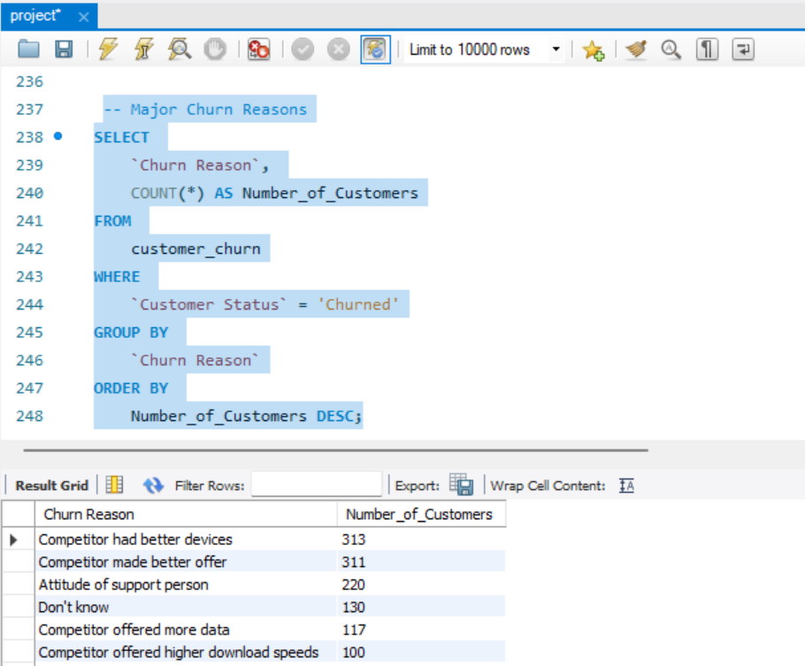

**How do the churn percentages across different categories correlate with the total revenue lost due to churn?**

**Data Summary:**

|  |  |  |
| --- | --- | --- |
| **Churn Category** | **Churned_Rev** | **Churn_Percentage** |
| Competitor | 1694413 | 45 |
| Dissatisfaction | 617979 | 18 |
| Attitude | 579554 | 17 |
| Price | 438124 | 12 |
| Other | 354389 | 10 |

* **Strong Correlation:** There is a clear correlation between the churn percentage and the total revenue lost, especially for the "Competitor" category, which leads in both metrics.
* **Dissatisfaction and Attitude:** These two categories also show a significant correlation, indicating that customer experience, beyond just pricing and competition, plays a crucial role in revenue retention.
* **Price Sensitivity:** While important, price-related churn has a moderate impact, suggesting that competitive pricing strategies, combined with improvements in service and customer satisfaction, could be more effective in reducing churn.

**SQL Query:**

